# CS 340 README

## About the Project/Project Title

This project is a web application to provide a user-friendly interface for a user to search for data in a database. This database is going to use MongoDB and with the database the user with be able to return combinations of breed, sex, and age of rescue animals.

## Motivation

The program was made to test my skill of working with databases and changing the data within them.

## Getting Started

To get started with the database:

1. We will use MONGO_USER=aacuser2, With MONGO_PASS=Password.
2. We will follow this with mongosh to enter in the mongoDB.
3. Next, we need to install python and run the program with jupyter.

## Installation

Tools needed for this to run include Jupiter notebooks, python, and mongoBD.

Jupyter Notebooks: Jupyter can be installed from the command line in any major operating system using the simple instructions here: https://jupyter.org/install. For detailed instructions like Proxy servers for Windows, Mac, and Linux, follow the instructions here: https://jupyterlab.readthedocs.io/en/stable/getting_started/installation.html.

Python: Detailed installation instructions for Python are available here:

https://realpython.com/installing-python/. Once you have Python installed, you should be able to use

this program from the Terminal on Mac or Linux or from the Command Prompt for Windo

Python: Detailed installation instructions for Python are available here: https://realpython.com/installing-python/. Once you have Python installed, you should be able to use this program from the Terminal on Mac or Linux or from the Command Prompt for Windows.

MongoDB: MongoDB comes in Community or Enterprise editions. Detailed instructions for the installation and downloading of MongoDB are available here: <https://docs.mongodb.com/manual/installation/>

## Usage

*Use this space to show useful examples of how your project works and how it can be used. Be sure to include examples of your code, tests, and screenshots.*

### Code Example

Create example.

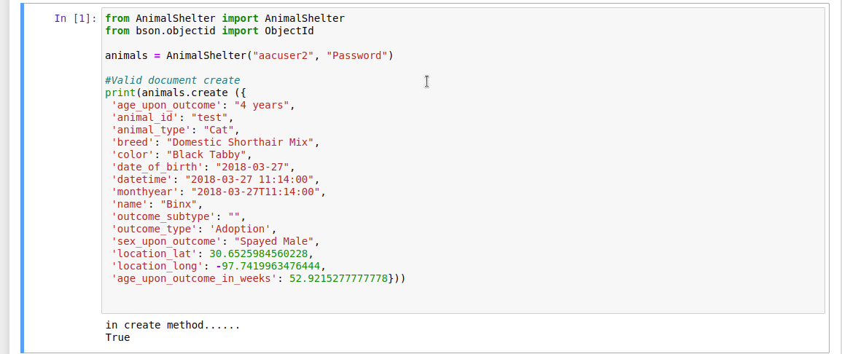

Read method.

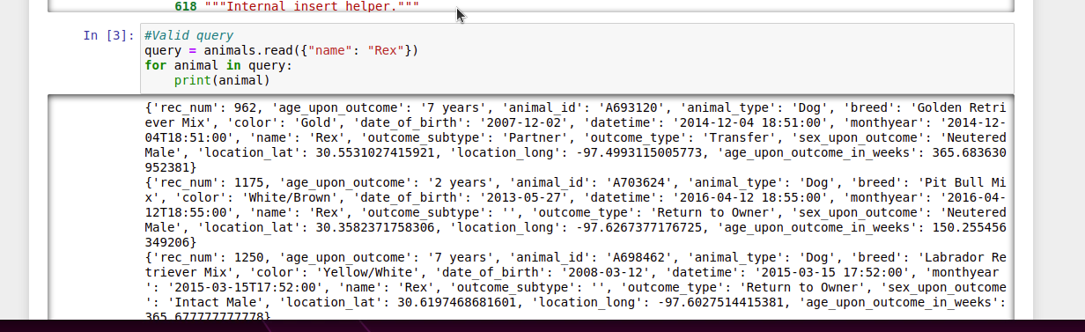

Update method.

Delete method.

### Tests

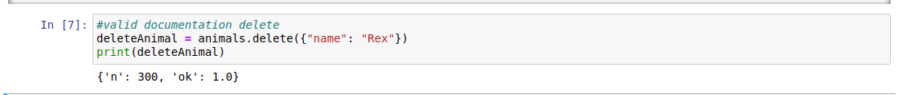

## Contact

Your name: Jospeh.ducharme@snhu.edu